Realtime e-commerce with MongoDB

Technical stack and how each is used
- HTML5: Semantic layout for navbar, header, product grid, modals.
- CSS3: Custom styles to refine Bootstrap components.
- Bootstrap: Responsive grid, cards, navbar, buttons via CDN.
- NodeJS: Runtime for server-side JavaScript and package scripts.
- jQuery: AJAX and DOM updates; listens to realtime events.
- ExpressJS: REST API and static file serving.
- MongoDB: Database for products and orders via Mongoose.
- Socket.IO: Realtime broadcasting of product updates and new orders.

Download & Install NodeJS in your system
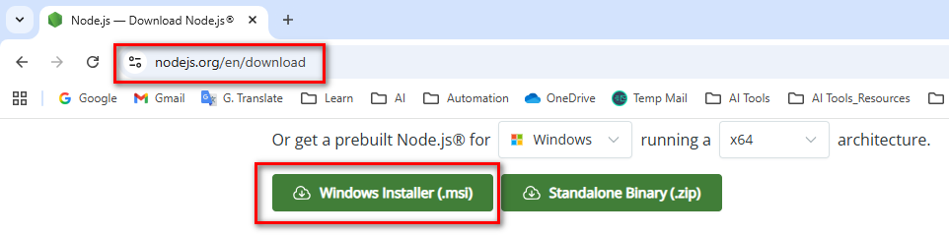

C:\WINDOWS\system32>node -v
v24.11.1

Install and configure local MongoDB
Install MongoDB Community Server
- Download: Go to mongodb.com → Community Server → download the installer for your OS.
https://www.mongodb.com/try/download/community
  - Run installer: Choose “Complete” setup.
  - Install MongoDB as a Service: Checked by default; keep defaults (runs on port 27017).
  - Tools: Include MongoDB Shell if available.
Verify MongoDB is running
- Check connection: The default URI is mongodb://localhost:27017.
- Optional shell:
  - Run mongosh → then show dbs.
  - If it connects, your local MongoDB is running.

Open your recently installed MongoDB on your system & also connect
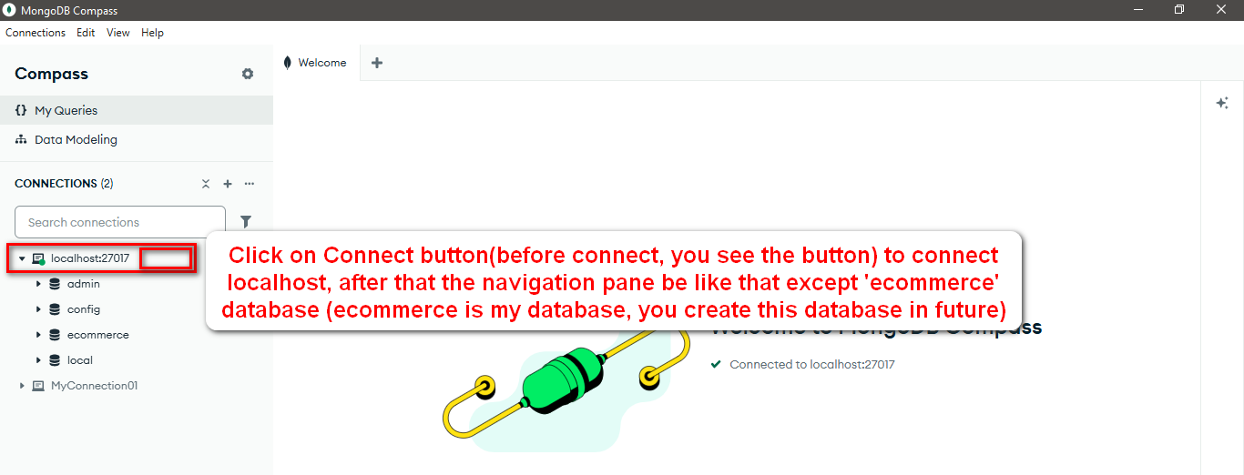

Prepare project in VS Code
- Create folder: ecommerce-realtime.
- Open in VS Code: File → Open Folder → ecommerce-realtime.
- Files: Create files exactly as named below and paste the code.

Install Node.js and dependencies
- Node.js: Install LTS if not already.
- Init and install:
  - Initialize: npm init -y
  - Install deps: npm install express mongoose cors dotenv morgan socket.io
  - Dev tool: npm install --save-dev nodemon

Run and test
- Seed products: npm run seed
- Run dev: npm run dev
- Open browser: http://localhost:3000
- Admin page: http://localhost:3000/admin.html
- Realtime test: Open two tabs; place an order in one; watch stock update in the other instantly.

Folder structure
- ecommerce-realtime/
  - package.json
  - .env
  - server.js
  - config/db.js
  - models/Product.js
  - models/Order.js
  - routes/api.js
  - routes/admin.js
  - seed/seed.js
  - public/
    - index.html
    - admin.html
    - css/styles.css
    - js/app.js
    - js/admin.js
    - img/ (optional)

package.json

{
"name": "ecommerce-realtime",
"version": "1.2.0",
"description": "Realtime e-Commerce using HTML5, CSS3, Bootstrap, NodeJS, jQuery, ExpressJS, MongoDB, Socket.IO",
"main": "server.js",
"scripts": {
"start": "node server.js",
"dev": "nodemon server.js",
"seed": "node seed/seed.js",
"zip": "zip -r ecommerce-realtime.zip . -x \"node_modules/*\""
},
"author": "Foysal",
"license": "MIT",
"dependencies": {
"cors": "^2.8.5",
"dotenv": "^16.4.0",
"express": "^4.19.2",
"mongoose": "^8.6.0",
"morgan": "^1.10.0",
"socket.io": "^4.7.5"
},
"devDependencies": {
"nodemon": "^3.1.0"
}
}

.env
PORT=3000
MONGODB_URI=mongodb://localhost:27017
DB_NAME=ecommerce

server.js
require('dotenv').config();
const path = require('path');
const express = require('express');
const morgan = require('morgan');
const cors = require('cors');
const http = require('http');
const { Server } = require('socket.io');

const connectDB = require('./config/db');
const apiRoutes = require('./routes/api');
const adminRoutes = require('./routes/admin');

const app = express();
const server = http.createServer(app);
const io = new Server(server, {
cors: { origin: '*' }
});

// Middleware
app.use(morgan('dev'));
app.use(cors());
app.use(express.json());
app.use(express.urlencoded({ extended: true }));

// Static files
app.use(express.static(path.join(__dirname, 'public')));

// API routes
app.use('/api', apiRoutes);
app.use('/admin', adminRoutes);

// Socket.IO
io.on('connection', (socket) => {
console.log('Client connected:', socket.id);
socket.on('disconnect', () => console.log('Client disconnected:', socket.id));
});

// Make io available in routes
app.set('io', io);

const PORT = process.env.PORT || 3000;

connectDB()
.then(() => {
server.listen(PORT, () => {
console.log(`Server running at http://localhost:${PORT}`);
});
})
.catch((err) => {
console.error('Failed to connect to MongoDB:', err.message);
process.exit(1);
});

config/db.js
const mongoose = require('mongoose');

async function connectDB() {
const uri = process.env.MONGODB_URI;
const dbName = process.env.DB_NAME || 'ecommerce';

if (!uri) {
throw new Error('MONGODB_URI is missing in .env');
}

await mongoose.connect(uri, { dbName });
console.log(`MongoDB connected to database: ${dbName}`);
}

module.exports = connectDB;

models/Product.js
const mongoose = require('mongoose');

const productSchema = new mongoose.Schema(
{
title: { type: String, required: true, trim: true },
description: { type: String, default: '' },
price: { type: Number, required: true, min: 0 },
currency: { type: String, default: 'BDT' },
imageUrl: { type: String, default: '' },
stock: { type: Number, default: 0, min: 0 },
category: { type: String, default: 'General' }
},
{ timestamps: true }
);

module.exports = mongoose.model('Product', productSchema);

models/Order.js
const mongoose = require('mongoose');

const orderItemSchema = new mongoose.Schema(
{
productId: { type: mongoose.Schema.Types.ObjectId, ref: 'Product', required: true },
title: { type: String, required: true },
quantity: { type: Number, required: true, min: 1 },
price: { type: Number, required: true, min: 0 }
},
{ _id: false }
);

const orderSchema = new mongoose.Schema(
{
customerName: { type: String, required: true },
customerEmail: { type: String, required: true },
items: { type: [orderItemSchema], required: true },
totalAmount: { type: Number, required: true, min: 0 },
status: { type: String, default: 'PLACED', enum: ['PLACED', 'CONFIRMED', 'SHIPPED', 'DELIVERED', 'CANCELLED'] }
},
{ timestamps: true }
);

module.exports = mongoose.model('Order', orderSchema);

routes/api.js
const express = require('express');
const Product = require('../models/Product');
const Order = require('../models/Order');

const router = express.Router();

// Health check
router.get('/health', (req, res) => res.json({ ok: true, timestamp: new Date().toISOString() }));

// Products list
router.get('/products', async (req, res) => {
try {
const products = await Product.find().sort({ createdAt: -1 });
res.json(products);
} catch {
res.status(500).json({ message: 'Failed to fetch products' });
}
});

// Create order
router.post('/orders', async (req, res) => {
try {
const { customerName, customerEmail, items } = req.body;
if (!customerName || !customerEmail || !Array.isArray(items) || items.length === 0) {
return res.status(400).json({ message: 'Invalid order payload' });
}

let totalAmount = 0;
for (const item of items) {
const product = await Product.findById(item.productId);
if (!product) return res.status(400).json({ message: 'Invalid product in order' });
if (product.stock < item.quantity) {
return res.status(400).json({ message: `Insufficient stock for ${product.title}` });
}
totalAmount += product.price * item.quantity;
product.stock -= item.quantity;
await product.save();
item.title = product.title;
item.price = product.price;
}

const order = await Order.create({
customerName,
customerEmail,
items,
totalAmount
});

// Emit realtime events
const io = req.app.get('io');
io.emit('productUpdate'); // products changed → refresh UI
io.emit('newOrder', order); // a new order appeared

res.status(201).json({ message: 'Order placed', order });
} catch (err) {
console.error(err);
res.status(500).json({ message: 'Failed to place order' });
}
});

// Orders list
router.get('/orders', async (req, res) => {
try {
const orders = await Order.find().sort({ createdAt: -1 });
res.json(orders);
} catch {
res.status(500).json({ message: 'Failed to fetch orders' });
}
});

module.exports = router;

routes/admin.js
const express = require('express');
const Product = require('../models/Product');

const router = express.Router();

// Create product
router.post('/products', async (req, res) => {
try {
const product = await Product.create(req.body);
const io = req.app.get('io');
io.emit('productUpdate');
res.status(201).json(product);
} catch (err) {
res.status(500).json({ message: 'Failed to create product' });
}
});

// Read all products
router.get('/products', async (req, res) => {
try {
const products = await Product.find().sort({ createdAt: -1 });
res.json(products);
} catch {
res.status(500).json({ message: 'Failed to fetch products' });
}
});

// Update product
router.put('/products/:id', async (req, res) => {
try {
const product = await Product.findByIdAndUpdate(req.params.id, req.body, { new: true });
if (!product) return res.status(404).json({ message: 'Product not found' });
const io = req.app.get('io');
io.emit('productUpdate');
res.json(product);
} catch {
res.status(500).json({ message: 'Failed to update product' });
}
});

// Delete product
router.delete('/products/:id', async (req, res) => {
try {
const product = await Product.findByIdAndDelete(req.params.id);
if (!product) return res.status(404).json({ message: 'Product not found' });
const io = req.app.get('io');
io.emit('productUpdate');
res.json({ message: 'Product deleted' });
} catch {
res.status(500).json({ message: 'Failed to delete product' });
}
});

module.exports = router;

seed/seed.js
require('dotenv').config();
const mongoose = require('mongoose');
const Product = require('../models/Product');

const uri = process.env.MONGODB_URI;
const dbName = process.env.DB_NAME || 'ecommerce';

const sampleProducts = [
{
title: 'NVIT Hoodie',
description: 'Comfortable cotton hoodie with NVIT branding',
price: 1499,
currency: 'BDT',
imageUrl: 'https://via.placeholder.com/600x400?text=NVIT+Hoodie',
stock: 20,
category: 'Apparel'
},
{
title: 'Power BI Guidebook',
description: 'Practical guide for dashboards and analytics',
price: 999,
currency: 'BDT',
imageUrl: 'https://via.placeholder.com/600x400?text=Power+BI+Guidebook',
stock: 50,
category: 'Books'
},
{
title: 'Excel Shortcuts Keyboard',
description: 'Printed shortcuts for faster data work',
price: 499,
currency: 'BDT',
imageUrl: 'https://via.placeholder.com/600x400?text=Excel+Keyboard',
stock: 35,
category: 'Accessories'
}
];

(async () => {
try {
await mongoose.connect(uri, { dbName });
console.log('Connected. Seeding products...');
await Product.deleteMany({});
await Product.insertMany(sampleProducts);
console.log('Seeding complete.');
process.exit(0);
} catch (err) {
console.error('Seeding failed:', err.message);
process.exit(1);
}
})();

public/index.html
<!DOCTYPE html>
<html lang="en">
<head>
<meta charset="UTF-8" />
<meta http-equiv="X-UA-Compatible" content="IE=edge" />
<meta name="viewport" content="width=device-width, initial-scale=1.0" />
<title>Realtime e-Commerce</title>

<!-- Bootstrap CSS -->
<link href="https://cdn.jsdelivr.net/npm/bootstrap@5.3.3/dist/css/bootstrap.min.css" rel="stylesheet" />
<link rel="stylesheet" href="/css/styles.css" />
</head>
<body>
<!-- Navbar -->
<nav class="navbar navbar-expand-lg navbar-dark bg-dark">
<div class="container">
<a class="navbar-brand fw-bold" href="#">NVIT Store</a>
<button class="navbar-toggler" type="button" data-bs-toggle="collapse" data-bs-target="#navContent">
<span class="navbar-toggler-icon"></span>
</button>
<div id="navContent" class="collapse navbar-collapse">
<ul class="navbar-nav ms-auto">
<li class="nav-item"><a class="nav-link active" href="#">Home</a></li>
<li class="nav-item"><a class="nav-link" href="#" id="viewOrdersLink">Orders</a></li>
<li class="nav-item"><a class="nav-link" href="#" id="viewCartLink">Cart (<span id="cartCount">0</span>)</a></li>
<li class="nav-item"><a class="nav-link" href="/admin.html">Admin</a></li>
</ul>
</div>
</div>
</nav>

<!-- Hero -->
<header class="bg-primary text-white py-5">
<div class="container text-center">
<h1 class="display-5">Realtime e-Commerce</h1>
<p class="lead">HTML5, CSS3, Bootstrap, jQuery, Node.js, Express.js, MongoDB (Local), Socket.IO</p>
</div>
</header>

<!-- Products -->
<section class="container my-4">
<h2 class="mb-3">Products</h2>
<div id="productGrid" class="row g-4"></div>
</section>

<!-- Cart Modal -->
<div class="modal fade" id="cartModal" tabindex="-1" aria-hidden="true">
<div class="modal-dialog modal-lg">
<div class="modal-content">
<div class="modal-header">
<h5 class="modal-title">Your Cart</h5>
<button type="button" class="btn-close" data-bs-dismiss="modal"></button>
</div>
<div class="modal-body">
<div id="cartItems"></div>
<hr />
<form id="checkoutForm" class="row g-3">
<div class="col-md-6">
<label class="form-label">Name</label>
<input type="text" class="form-control" id="customerName" required />
</div>
<div class="col-md-6">
<label class="form-label">Email</label>
<input type="email" class="form-control" id="customerEmail" required />
</div>
<div class="col-12 d-flex justify-content-between align-items-center">
<h5>Total: <span id="cartTotal">0</span> BDT</h5>
<button type="submit" class="btn btn-success">Place Order</button>
</div>
</form>
<div id="checkoutMsg" class="mt-3"></div>
</div>
</div>
</div>
</div>

<!-- Orders Modal -->
<div class="modal fade" id="ordersModal" tabindex="-1" aria-hidden="true">
<div class="modal-dialog modal-lg">
<div class="modal-content">
<div class="modal-header">
<h5 class="modal-title">Recent Orders</h5>
<button type="button" class="btn-close" data-bs-dismiss="modal"></button>
</div>
<div class="modal-body">
<div id="ordersList"></div>
</div>
</div>
</div>
</div>

<!-- jQuery + Bootstrap JS -->
<script src="https://code.jquery.com/jquery-3.7.1.min.js"></script>
<script src="https://cdn.jsdelivr.net/npm/bootstrap@5.3.3/dist/js/bootstrap.bundle.min.js"></script>
<!-- Socket.IO client -->
<script src="/socket.io/socket.io.js"></script>
<!-- App JS -->
<script src="/js/app.js"></script>
</body>
</html>

public/admin.html
<!DOCTYPE html>
<html lang="en">
<head>
<meta charset="UTF-8" />
<title>Admin Dashboard</title>
<link href="https://cdn.jsdelivr.net/npm/bootstrap@5.3.3/dist/css/bootstrap.min.css" rel="stylesheet" />
</head>
<body class="bg-light">
<div class="container py-4">
<h1 class="mb-4">Admin Dashboard</h1>
<p class="mb-3"><a href="/" class="btn btn-outline-secondary btn-sm">← Back to Store</a></p>

<!-- Add Product Form -->
<form id="addProductForm" class="row g-3 mb-4">
<div class="col-md-4"><input type="text" class="form-control" id="title" placeholder="Title" required /></div>
<div class="col-md-4"><input type="number" class="form-control" id="price" placeholder="Price" required /></div>
<div class="col-md-4"><input type="number" class="form-control" id="stock" placeholder="Stock" required /></div>
<div class="col-md-6"><input type="text" class="form-control" id="imageUrl" placeholder="Image URL" /></div>
<div class="col-md-6"><input type="text" class="form-control" id="category" placeholder="Category" /></div>
<div class="col-md-12"><textarea class="form-control" id="description" placeholder="Description"></textarea></div>
<div class="col-md-12"><button type="submit" class="btn btn-primary">Add Product</button></div>
</form>

<!-- Product List -->
<table class="table table-bordered">
<thead><tr><th>Title</th><th>Price</th><th>Stock</th><th>Actions</th></tr></thead>
<tbody id="productTable"></tbody>
</table>
</div>

<script src="https://code.jquery.com/jquery-3.7.1.min.js"></script>
<script src="/socket.io/socket.io.js"></script>
<script src="/js/admin.js"></script>
</body>
</html>

public/css/styles.css
body {
background-color: #f8f9fa;
}

.card-title {
font-weight: 600;
}

.price-tag {
font-size: 1rem;
font-weight: 600;
color: #0d6efd;
}

.navbar-brand {
letter-spacing: 0.5px;
}

#cartItems .cart-row {
display: flex;
justify-content: space-between;
align-items: center;
padding: 6px 0;
}

#checkoutMsg {
min-height: 24px;
}

public/js/app.js
// Frontend logic with jQuery + Socket.IO realtime

const cartKey = 'nvit_cart';
const socket = io();

function getCart() {
const raw = localStorage.getItem(cartKey);
return raw ? JSON.parse(raw) : [];
}

function saveCart(items) {
localStorage.setItem(cartKey, JSON.stringify(items));
updateCartCount();
}

function updateCartCount() {
const items = getCart();
const totalQty = items.reduce((sum, it) => sum + it.quantity, 0);
$('#cartCount').text(totalQty);
}

function addToCart(product, qty = 1) {
const cart = getCart();
const existing = cart.find((c) => c.productId === product._id);
if (existing) {
existing.quantity += qty;
} else {
cart.push({
productId: product._id,
title: product.title,
price: product.price,
quantity: qty
});
}
saveCart(cart);
}

function renderProducts(products) {
const grid = $('#productGrid');
grid.empty();

products.forEach((p) => {
const col = $(`
<div class="col-md-4 col-sm-6">
<div class="card h-100">
<img src="${p.imageUrl || 'https://via.placeholder.com/600x400?text=Product'}" class="card-img-top" alt="${p.title}" />
<div class="card-body d-flex flex-column">
<h5 class="card-title">${p.title}</h5>
<p class="card-text">${p.description || ''}</p>
<div class="d-flex justify-content-between align-items-center mt-auto">
<span class="price-tag">${p.price} ${p.currency || 'BDT'}</span>
<button class="btn btn-primary btn-sm" ${p.stock <= 0 ? 'disabled' : ''}>${p.stock <= 0 ? 'Out of Stock' : 'Add to Cart'}</button>
</div>
<small class="text-muted mt-1">Stock: ${p.stock}</small>
</div>
</div>
</div>
`);

col.find('button').on('click', () => addToCart(p, 1));
grid.append(col);
});
}

function renderCart() {
const items = getCart();
const container = $('#cartItems');
container.empty();

if (items.length === 0) {
container.html('<p class="text-muted">Your cart is empty.</p>');
$('#cartTotal').text(0);
return;
}

let total = 0;
items.forEach((it, idx) => {
total += it.price * it.quantity;
const row = $(`
<div class="cart-row">
<div><strong>${it.title}</strong> — ${it.price} BDT x ${it.quantity}</div>
<div>
<button class="btn btn-outline-secondary btn-sm me-2" data-idx="${idx}" data-action="dec">-</button>
<button class="btn btn-outline-secondary btn-sm me-2" data-idx="${idx}" data-action="inc">+</button>
<button class="btn btn-outline-danger btn-sm" data-idx="${idx}" data-action="remove">Remove</button>
</div>
</div>
`);
container.append(row);
});

$('#cartTotal').text(total);

container.find('button').on('click', function () {
const idx = parseInt($(this).data('idx'), 10);
const action = $(this).data('action');
const cart = getCart();

if (action === 'dec') {
cart[idx].quantity = Math.max(1, cart[idx].quantity - 1);
} else if (action === 'inc') {
cart[idx].quantity += 1;
} else if (action === 'remove') {
cart.splice(idx, 1);
}

saveCart(cart);
renderCart();
});
}

function placeOrder(name, email) {
const items = getCart();
if (items.length === 0) return { ok: false, message: 'Cart is empty' };

const payload = {
customerName: name,
customerEmail: email,
items: items.map((it) => ({
productId: it.productId,
quantity: it.quantity
}))
};

return $.ajax({
url: '/api/orders',
method: 'POST',
contentType: 'application/json',
data: JSON.stringify(payload)
});
}

function fetchOrders() {
return $.get('/api/orders');
}

function loadProducts() {
$.get('/api/products').then(renderProducts);
}

$(function () {
updateCartCount();
loadProducts();

// Realtime events
socket.on('productUpdate', () => {
loadProducts();
});

socket.on('newOrder', (order) => {
console.log('New order:', order);
if ($('#ordersModal').hasClass('show')) {
fetchOrders().then((orders) => {
const container = $('#ordersList');
container.empty();
orders.forEach((o) => {
const itemsText = o.items.map((i) => `${i.title} x ${i.quantity} (${i.price} BDT)`).join(', ');
const card = $(`
<div class="border rounded p-2 mb-2">
<div><strong>${o.customerName}</strong> — ${o.customerEmail}</div>
<div>Items: ${itemsText}</div>
<div>Total: ${o.totalAmount} BDT</div>
<small class="text-muted">Status: ${o.status} | ${new Date(o.createdAt).toLocaleString()}</small>
</div>
`);
container.append(card);
});
});
}
});

// Cart modal
const cartModal = new bootstrap.Modal('#cartModal');
$('#viewCartLink').on('click', (e) => {
e.preventDefault();
renderCart();
cartModal.show();
});

// Orders modal
const ordersModal = new bootstrap.Modal('#ordersModal');
$('#viewOrdersLink').on('click', (e) => {
e.preventDefault();
fetchOrders().then((orders) => {
const container = $('#ordersList');
container.empty();
if (!orders || orders.length === 0) {
container.html('<p class="text-muted">No orders yet.</p>');
return;
}
orders.forEach((o) => {
const itemsText = o.items.map((i) => `${i.title} x ${i.quantity} (${i.price} BDT)`).join(', ');
const card = $(`
<div class="border rounded p-2 mb-2">
<div><strong>${o.customerName}</strong> — ${o.customerEmail}</div>
<div>Items: ${itemsText}</div>
<div>Total: ${o.totalAmount} BDT</div>
<small class="text-muted">Status: ${o.status} | ${new Date(o.createdAt).toLocaleString()}</small>
</div>
`);
container.append(card);
});
ordersModal.show();
});
});

// Checkout
$('#checkoutForm').on('submit', function (e) {
e.preventDefault();
const name = $('#customerName').val().trim();
const email = $('#customerEmail').val().trim();

$('#checkoutMsg').removeClass().addClass('text-muted').text('Placing order...');
placeOrder(name, email)
.then(() => {
$('#checkoutMsg').removeClass().addClass('text-success').text('Order placed successfully!');
saveCart([]); // clear cart
renderCart();
})
.catch((xhr) => {
const msg = xhr?.responseJSON?.message || 'Order failed';
$('#checkoutMsg').removeClass().addClass('text-danger').text(msg);
});
});
});

public/js/admin.js
const socket = io();

function loadProducts() {
$.get('/admin/products').then((products) => {
const table = $('#productTable');
table.empty();
products.forEach((p) => {
const row = $(`
<tr>
<td>${p.title}</td>
<td><input type="number" class="form-control form-control-sm price-input" data-id="${p._id}" value="${p.price}" /></td>
<td><input type="number" class="form-control form-control-sm stock-input" data-id="${p._id}" value="${p.stock}" /></td>
<td>
<button class="btn btn-success btn-sm update-btn" data-id="${p._id}">Update</button>
<button class="btn btn-danger btn-sm delete-btn" data-id="${p._id}">Delete</button>
</td>
</tr>
`);
table.append(row);
});
});
}

$(function () {
loadProducts();

// Realtime refresh
socket.on('productUpdate', () => {
loadProducts();
});

// Add product
$('#addProductForm').on('submit', function (e) {
e.preventDefault();
const payload = {
title: $('#title').val(),
price: Number($('#price').val()),
stock: Number($('#stock').val()),
imageUrl: $('#imageUrl').val(),
category: $('#category').val(),
description: $('#description').val()
};
$.post('/admin/products', payload).then(() => {
this.reset();
loadProducts();
});
});

// Update product
$(document).on('click', '.update-btn', function () {
const id = $(this).data('id');
const price = Number($(`.price-input[data-id="${id}"]`).val());
const stock = Number($(`.stock-input[data-id="${id}"]`).val());
$.ajax({
url: `/admin/products/${id}`,
method: 'PUT',
contentType: 'application/json',
data: JSON.stringify({ price, stock })
}).then(() => loadProducts());
});

// Delete product
$(document).on('click', '.delete-btn', function () {
const id = $(this).data('id');
$.ajax({ url: `/admin/products/${id}`, method: 'DELETE' }).then(() => loadProducts());
});
});

Run and test
- Run dev: npm run dev
- Open browser: http://localhost:3000
- Admin page: http://localhost:3000/admin.html
- Realtime test: Open two tabs; place an order in one; watch stock update in the other instantly.

Now, you can place an order through Cart & also you can add a product from admin section. All tasks perform real-time.

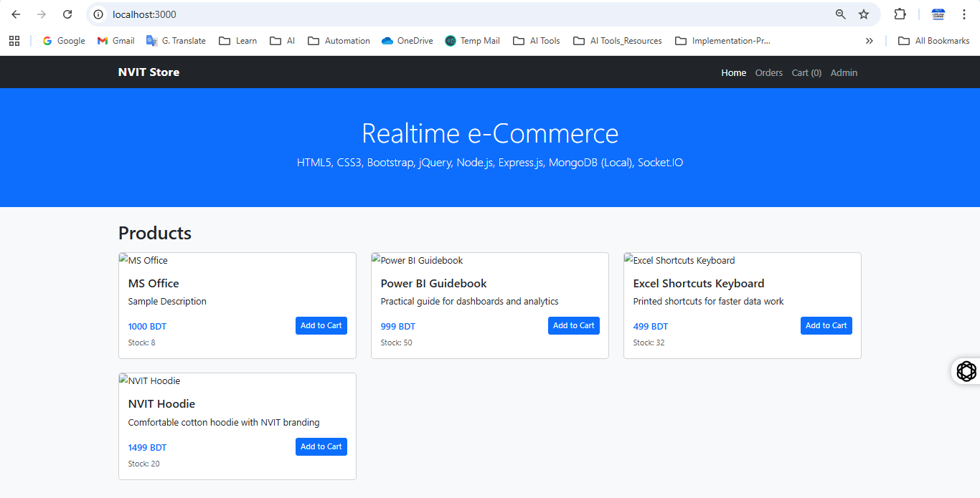

Check the database table values
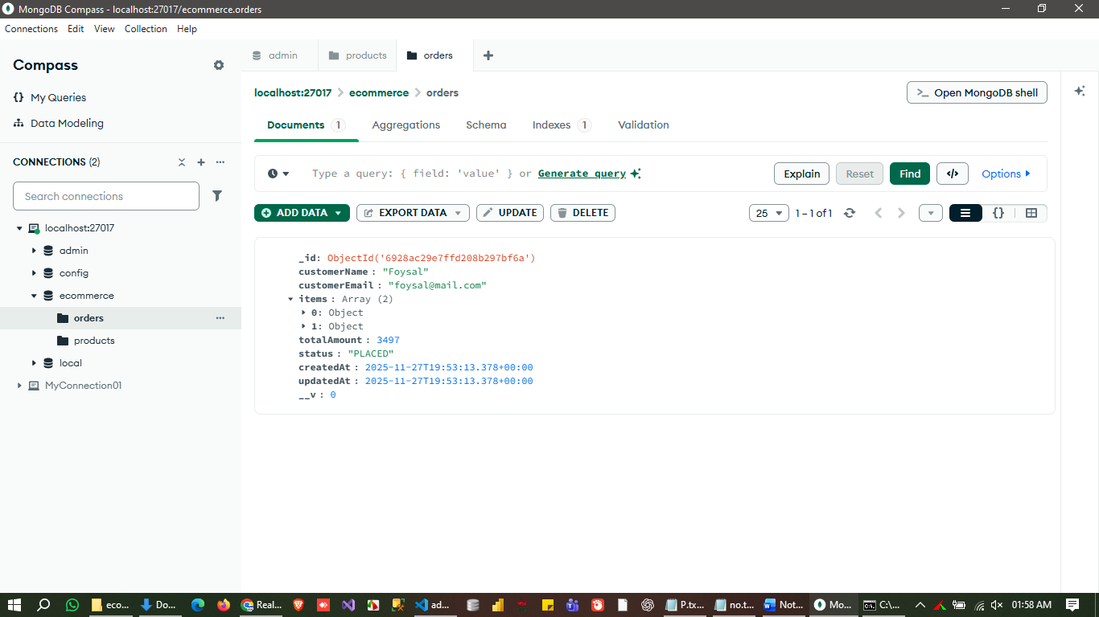

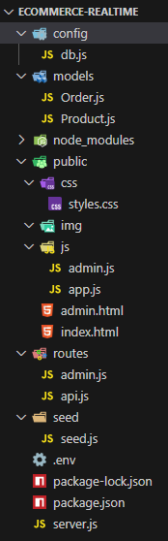

Project Structure

